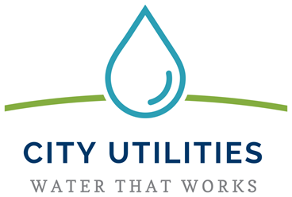
fluorescent & led light bulb recycling

Fluorescent light bulbs contain a pen tip amount of mercury, a nerve toxin that affects the way an individual functions. Broken fluorescent bulbs can release mercury in landfills and contaminate the air we breathe, as well as poison our waterways and the foods we eat.

Allen County residents are encouraged to bring their bulbs to specially marked containers located at the following locations:
Connolly’s Do It Best
515 E Dupont Rd.
Connolly’s Do It Best
1642 Wells St.
Connolly’s Do It Best
5221 S. Calhoun St.
Connolly’s Do It Best
10301 Illinois Rd.
Grabill Hardware
13534 Main St, Grabill
Umber’s Do It Best
2413 Lower Huntington Rd
Umber’s Do It Best
2814 Maplecrest Rd.
(Accepts bulbs up to 8 foot in length, CFLs & LEDs)
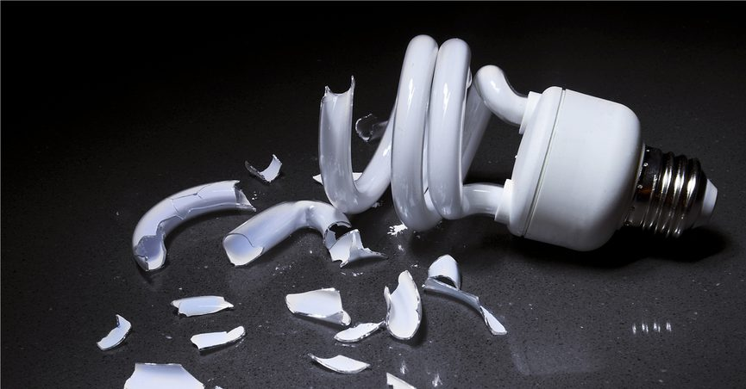
Residents can also recycle bulbs every Tuesday from 9am to 2pm at ACDEM’s HHW facility at 2260 Carroll Road
Businesses interested in disposing fluorescent and or/LED bulbs should call ACDEM’s Household Hazardous Waste Coordinator at 260-449-4433 to make arrangements.
Revised: July 2019

