Mercury spill Clean- up

- Never use a vacuum cleaner or broom to clean up the spill.

- Never pour mercury down a drain.

- Never use a washing machine to launder clothing or other items that may have come in contact with mercury.

- Never allow people who are wearing mercury contaminated shoes or clothing to walk around the house.
- If the weather allows, open exterior doors and windows. Keeps air flowing through the room to the outside but close doors to other parts of the building to avoid spreading the contamination.
- Close all heating and air-conditioning vents in the room until the clean-up is finished.
- Contain the spill. Build a berm around the mercury with rags or other disposable material to keep it from spreading
- If the spill was on a hard surface, work from the outside of the spill toward the center. Use a card, stiff paper or a plastic squeegee to push the mercury together to form larger and larger droplets.
- Push the droplets into a plastic dustpan or pick them up with an eye dropper or turkey baster. You may also be able to pick up small droplets with tape, but be careful. The drops won't always stick.
- Collect all of the mercury into a sealable plastic bag or a plastic container with a lid that will seal tightly.
- The mercury and anything that has come into contact with it should be taken to a hazardous waste recycling facility for appropriate disposal.
Useful items for cleaning up Mercury
- Rubber squeegee
- Plastic dust pan
- Plastic trash bag
- Zip-shut plastic bag
- Plastic container with a screw on or other leak-proof lid
- Eye dropper or other suction device such as turkey baster
- Index cards or stiff paper
- Tape – electrical or duct tape works best
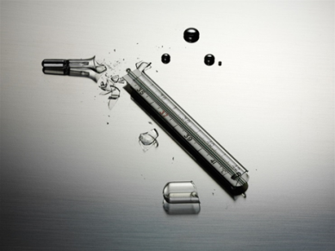
For large spills or when in doubt about what to do, call:
Fort Wayne Water Pollution Control Plant at 260-427-1243
Call the Indiana Department of Environmental Management (IDEM) Spill Line toll-free at (888) 233-7745. IDEM personnel can determine if IDEM and or US Environmental Protection Agency staff should be called in to perform a clean-up operation.

